**PostgreSQL Exercise II**

**Exercise 1: Joins and Aggregation**

1) Create a table called "Orders" with columns: "OrderID," "CustomerID," "OrderDate," and "TotalAmount."

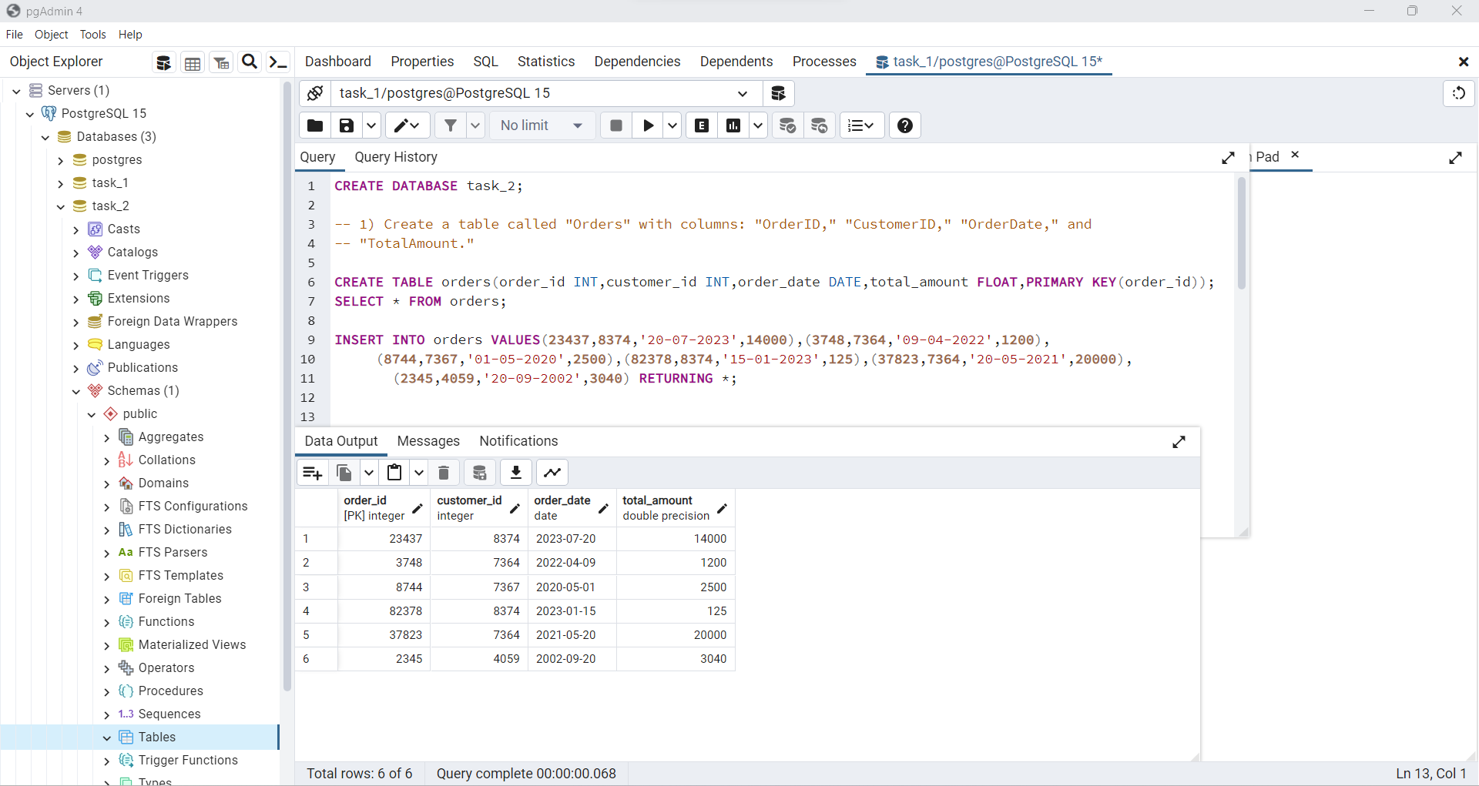

2) Create a table called "OrderItems" with columns: "OrderItemID," "OrderID," "ProductID," "Quantity," and "UnitPrice."

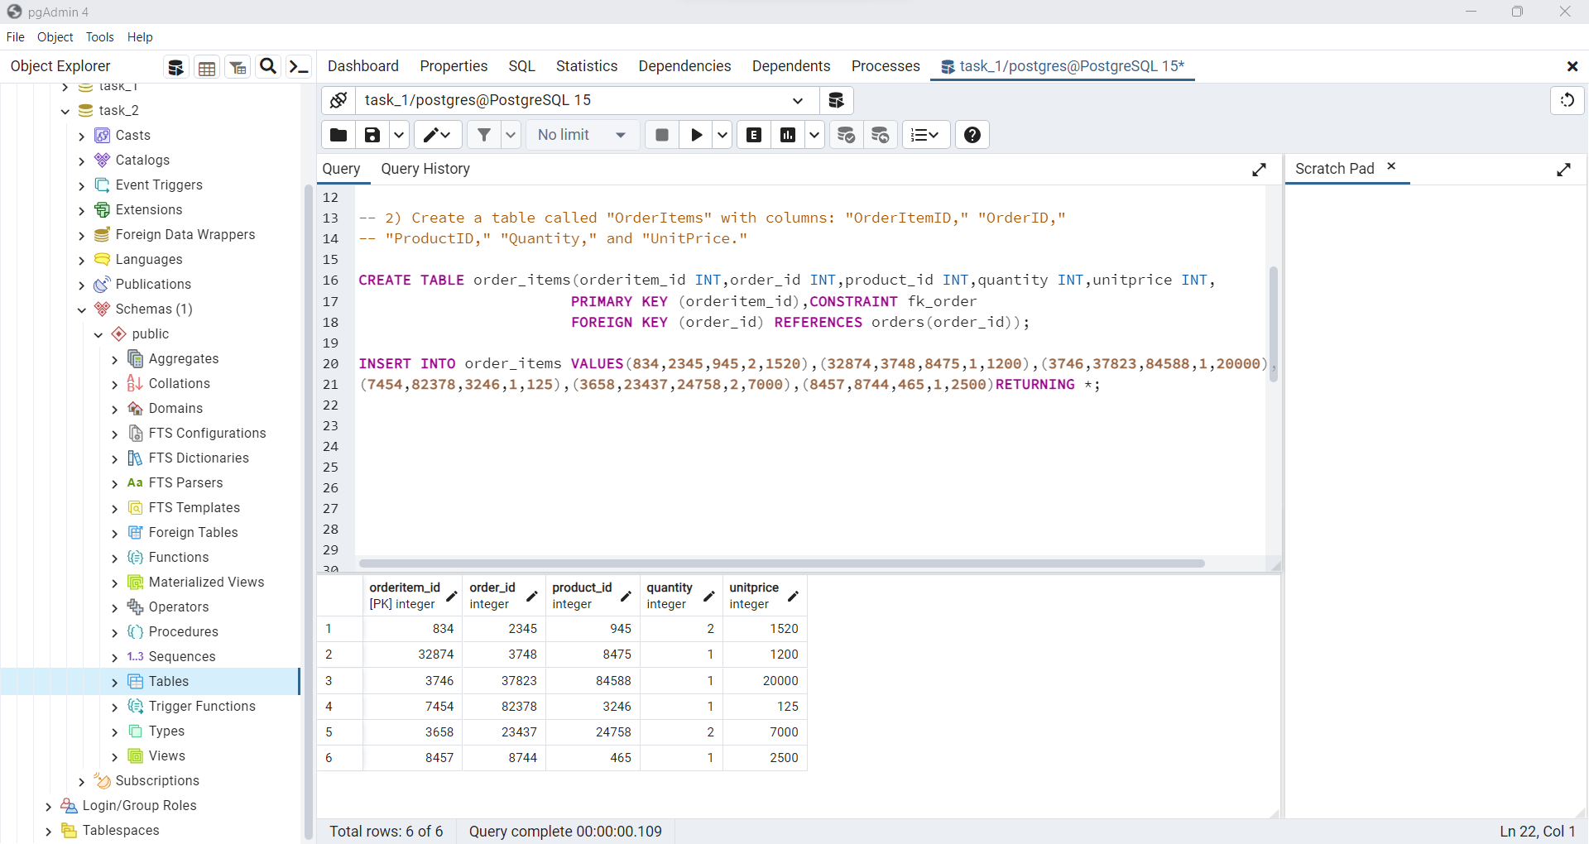

3) Write a query to retrieve the total amount and number of items for each order placed by a specific customer.

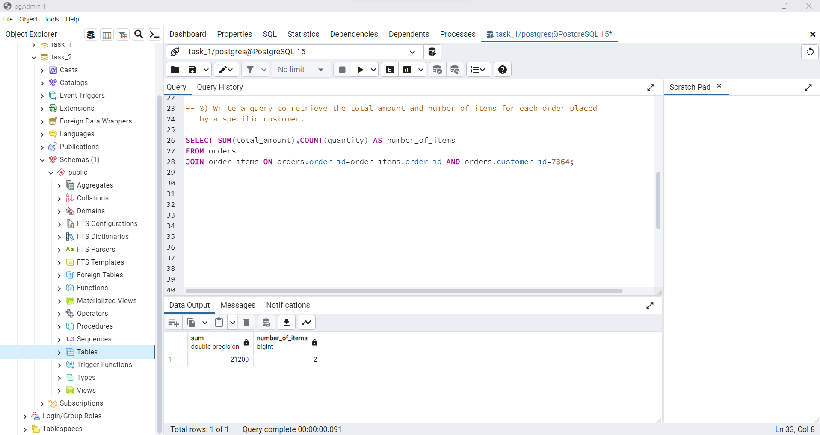

**Exercise 2: Common Table Expressions (CTEs)**

1) Create a CTE that lists the total sales amount for each product using the "Orders" and "OrderItems" tables.

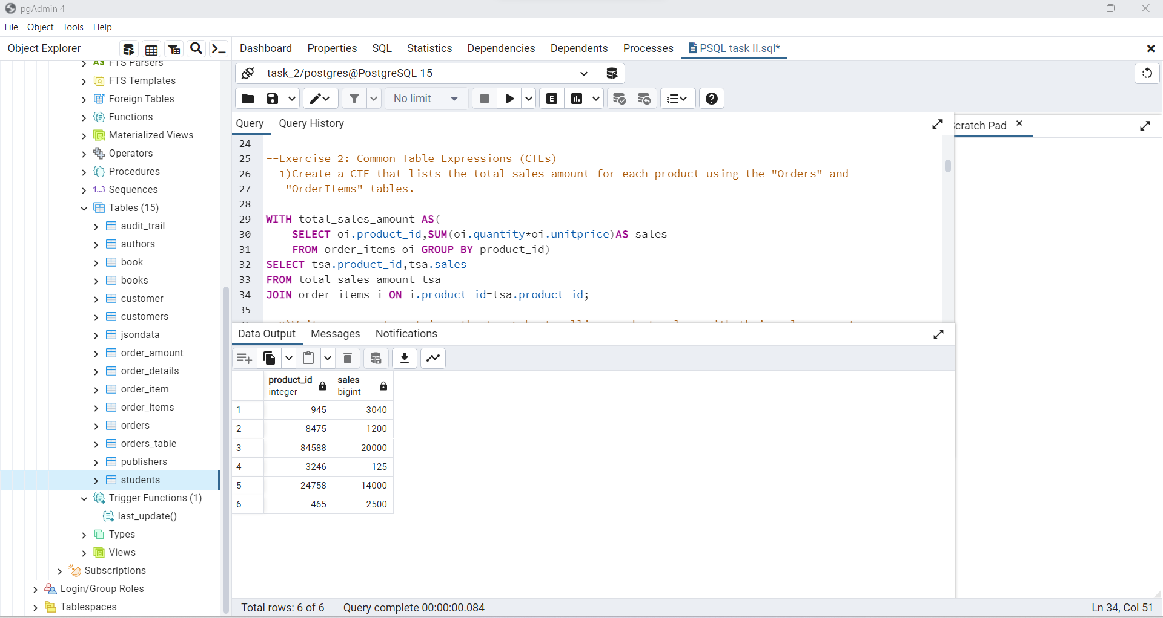

2) Write a query to retrieve the top 5 best-selling products along with their sales amounts.

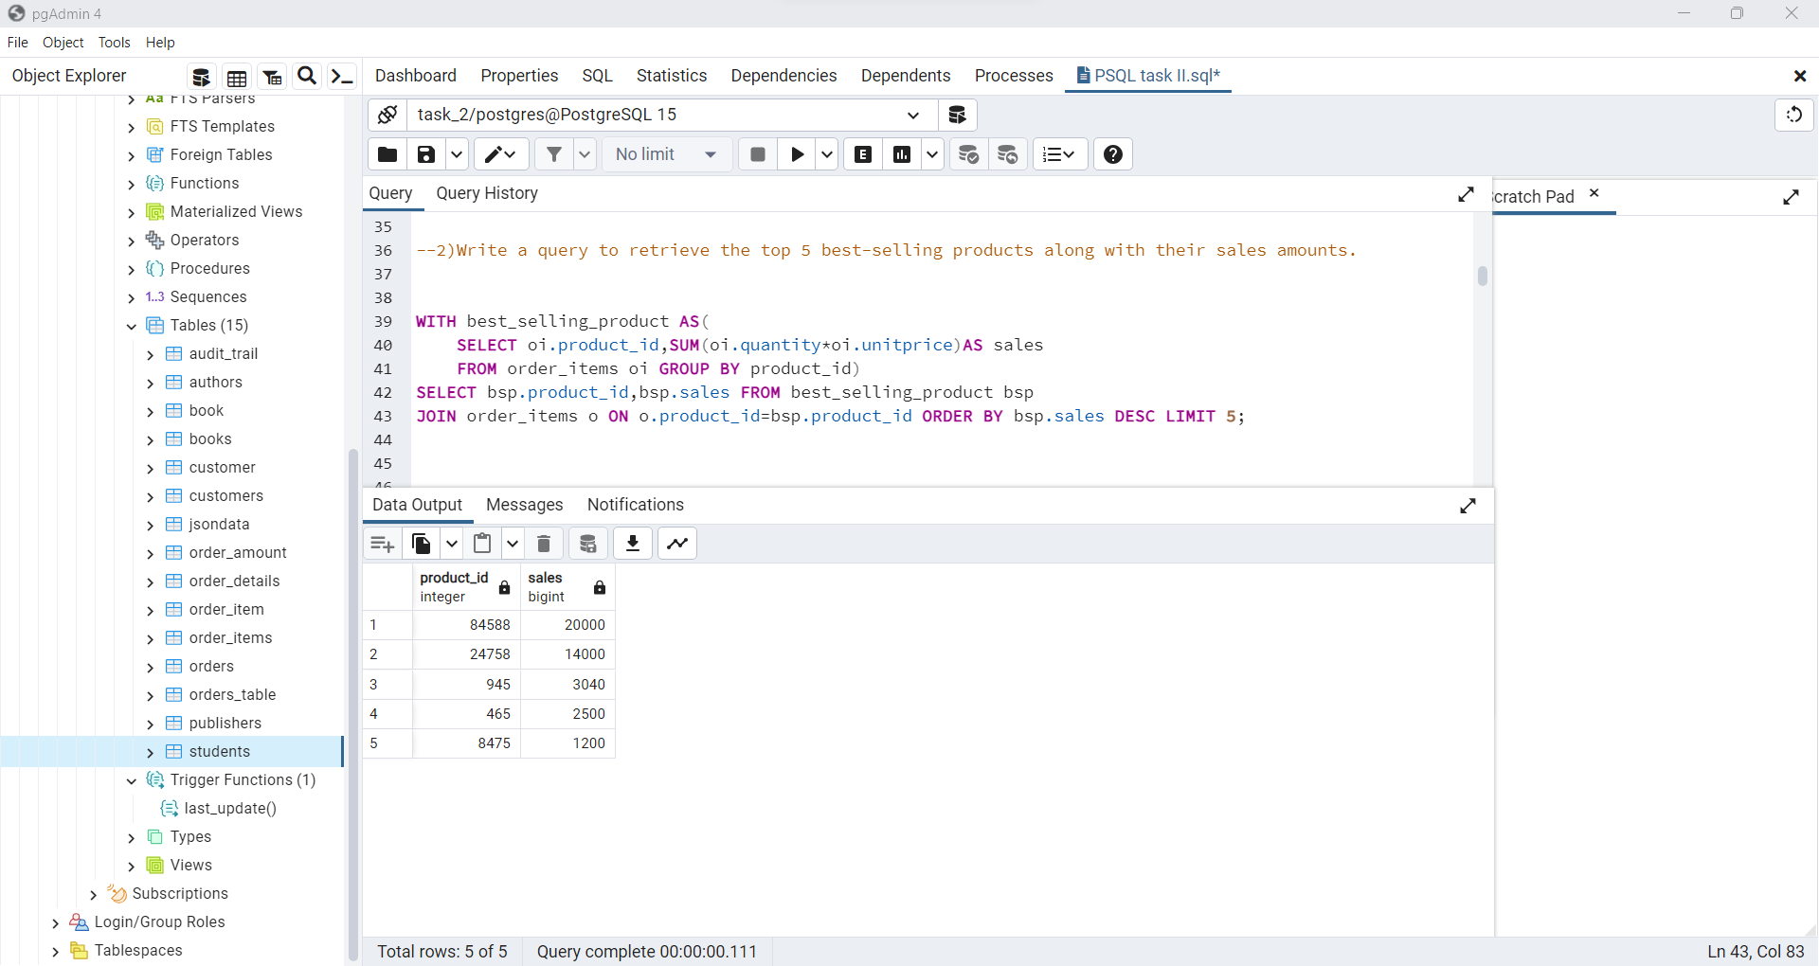

**Exercise 3: Window Functions**

1) Write a query to calculate the cumulative sum of the "TotalAmount" for each order, ordered by "OrderDate."

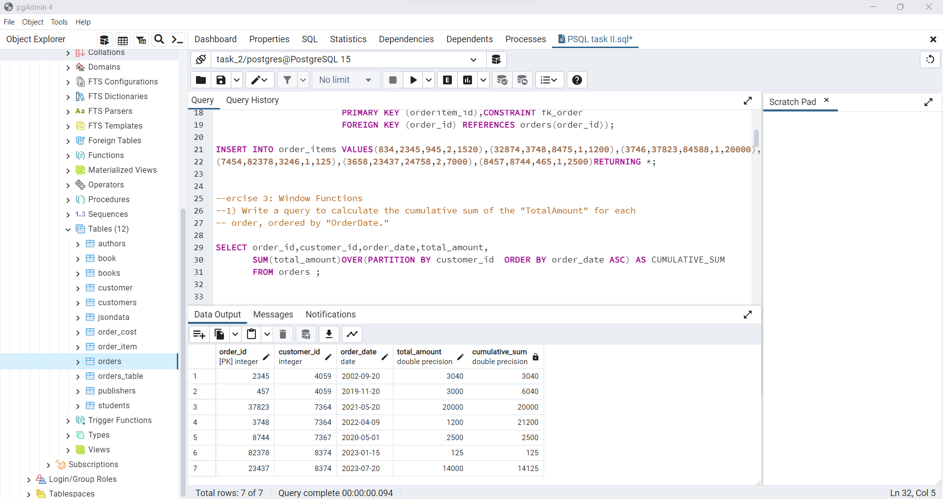

2) Calculate the difference between the current row's "TotalAmount" and the previous row's "TotalAmount."

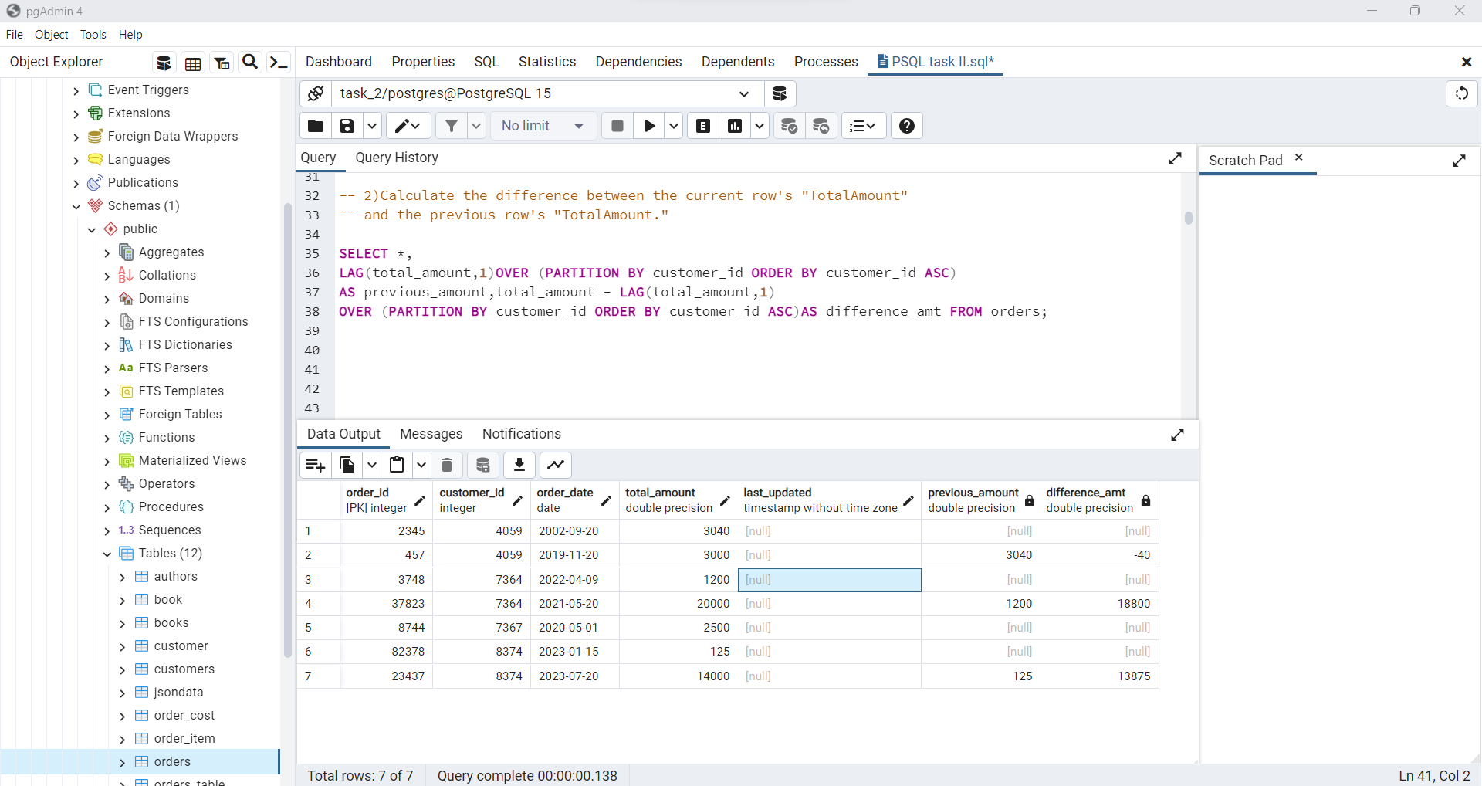

**Exercise 4: Subqueries and EXISTS**

1)Write a query to retrieve customers who have placed orders in the last 30 days.

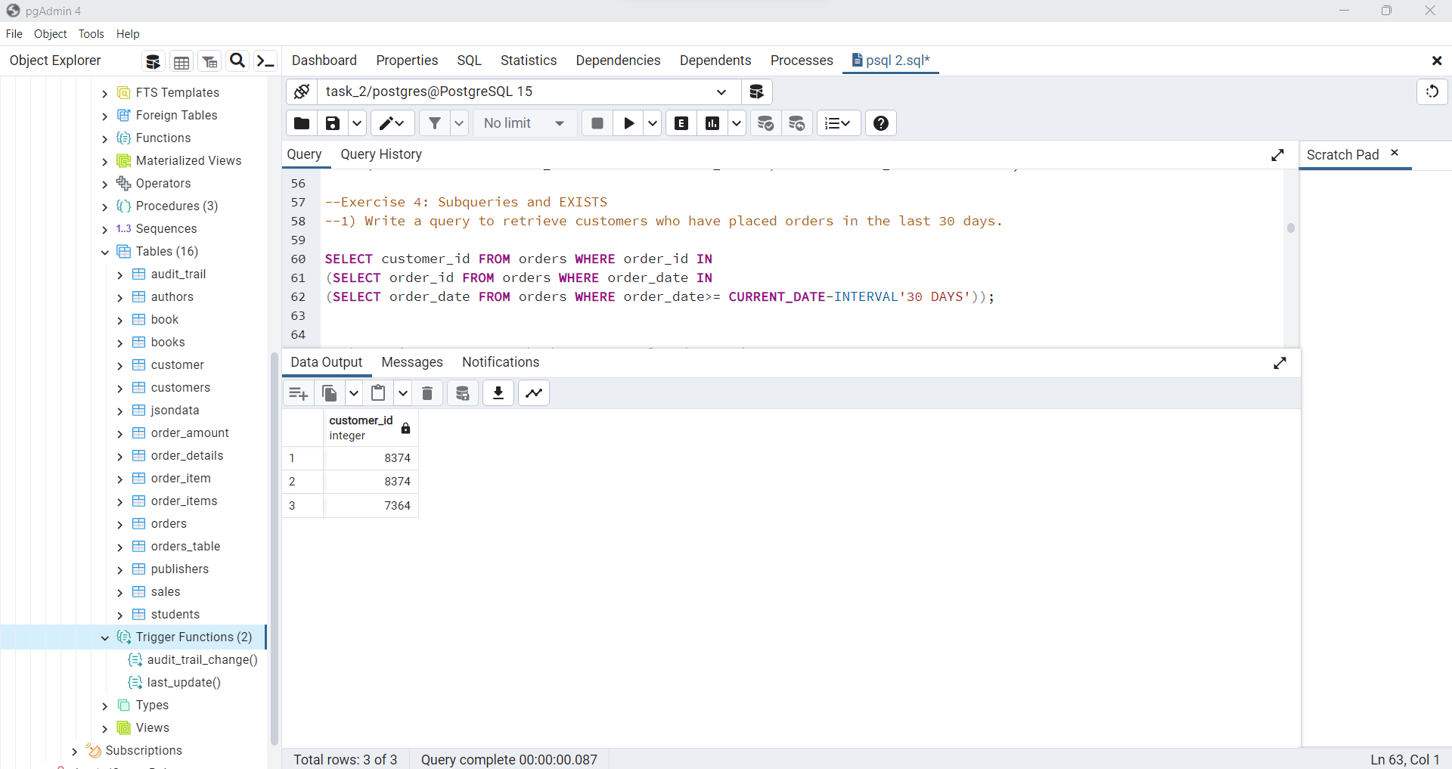

2) Retrieve customers who have never placed an order.

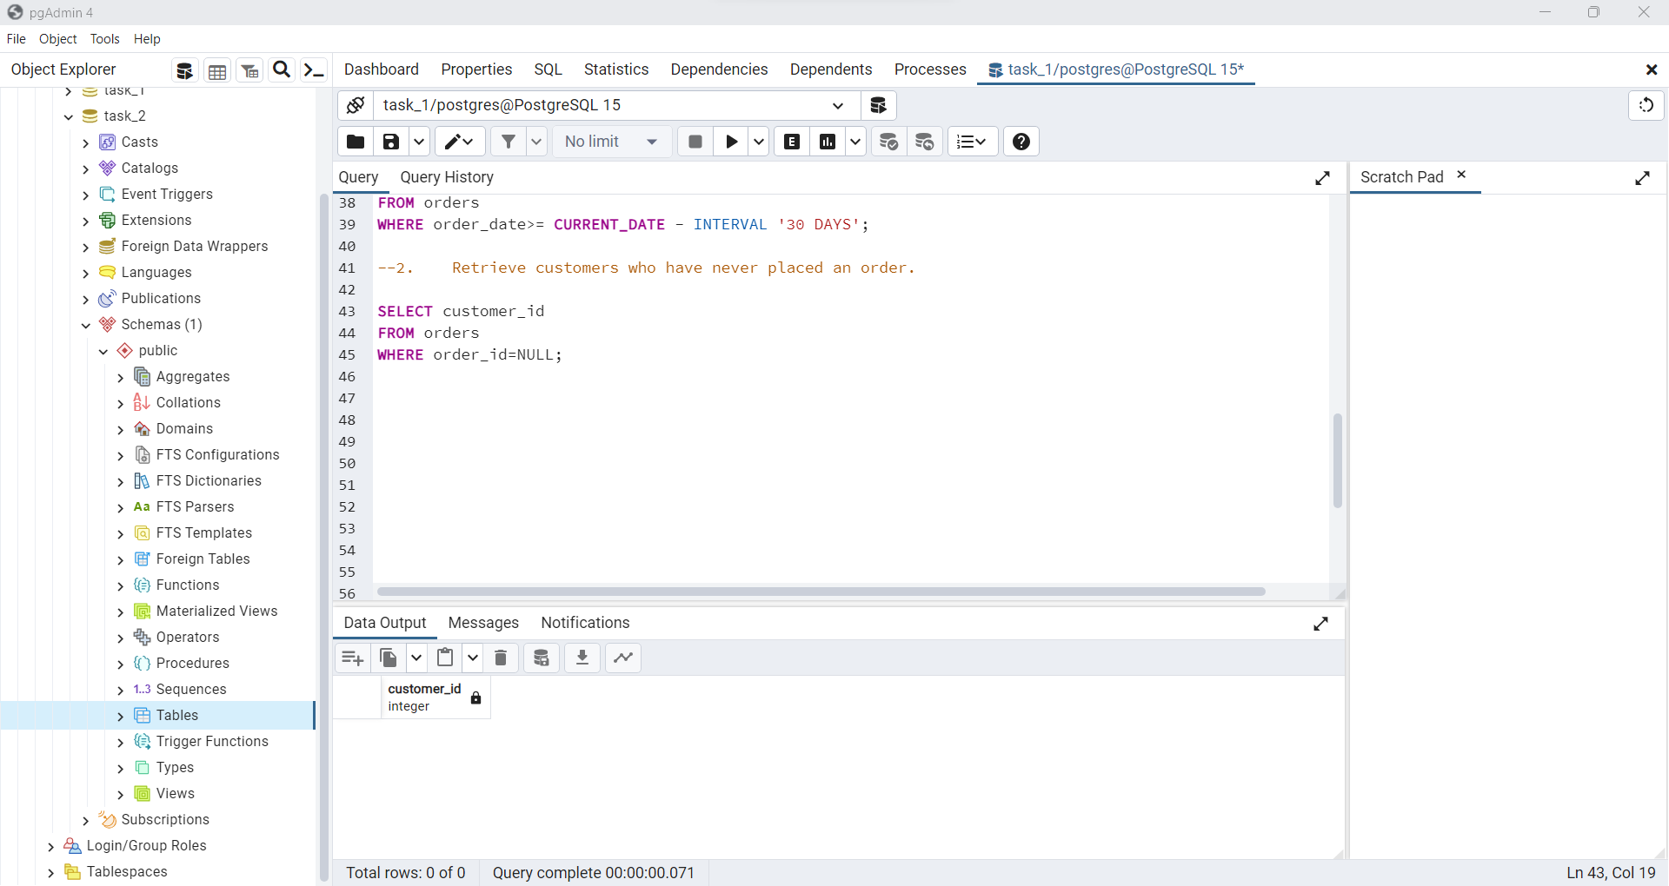

**Exercise 5: Advanced Filtering and Subqueries**

1)Retrieve customers who have placed orders with a total amount greater than the average total amount of all orders.

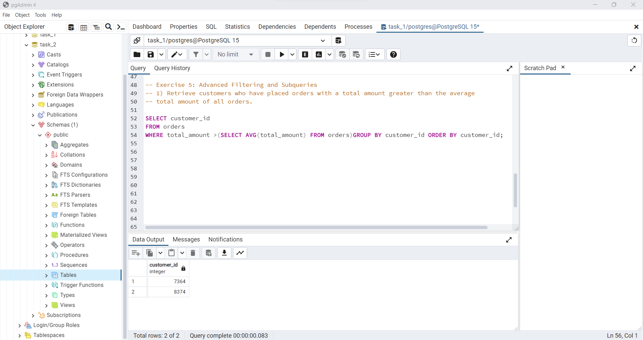

2) Retrieve customers who have placed orders with a total amount greater than the average total amount of their own orders.

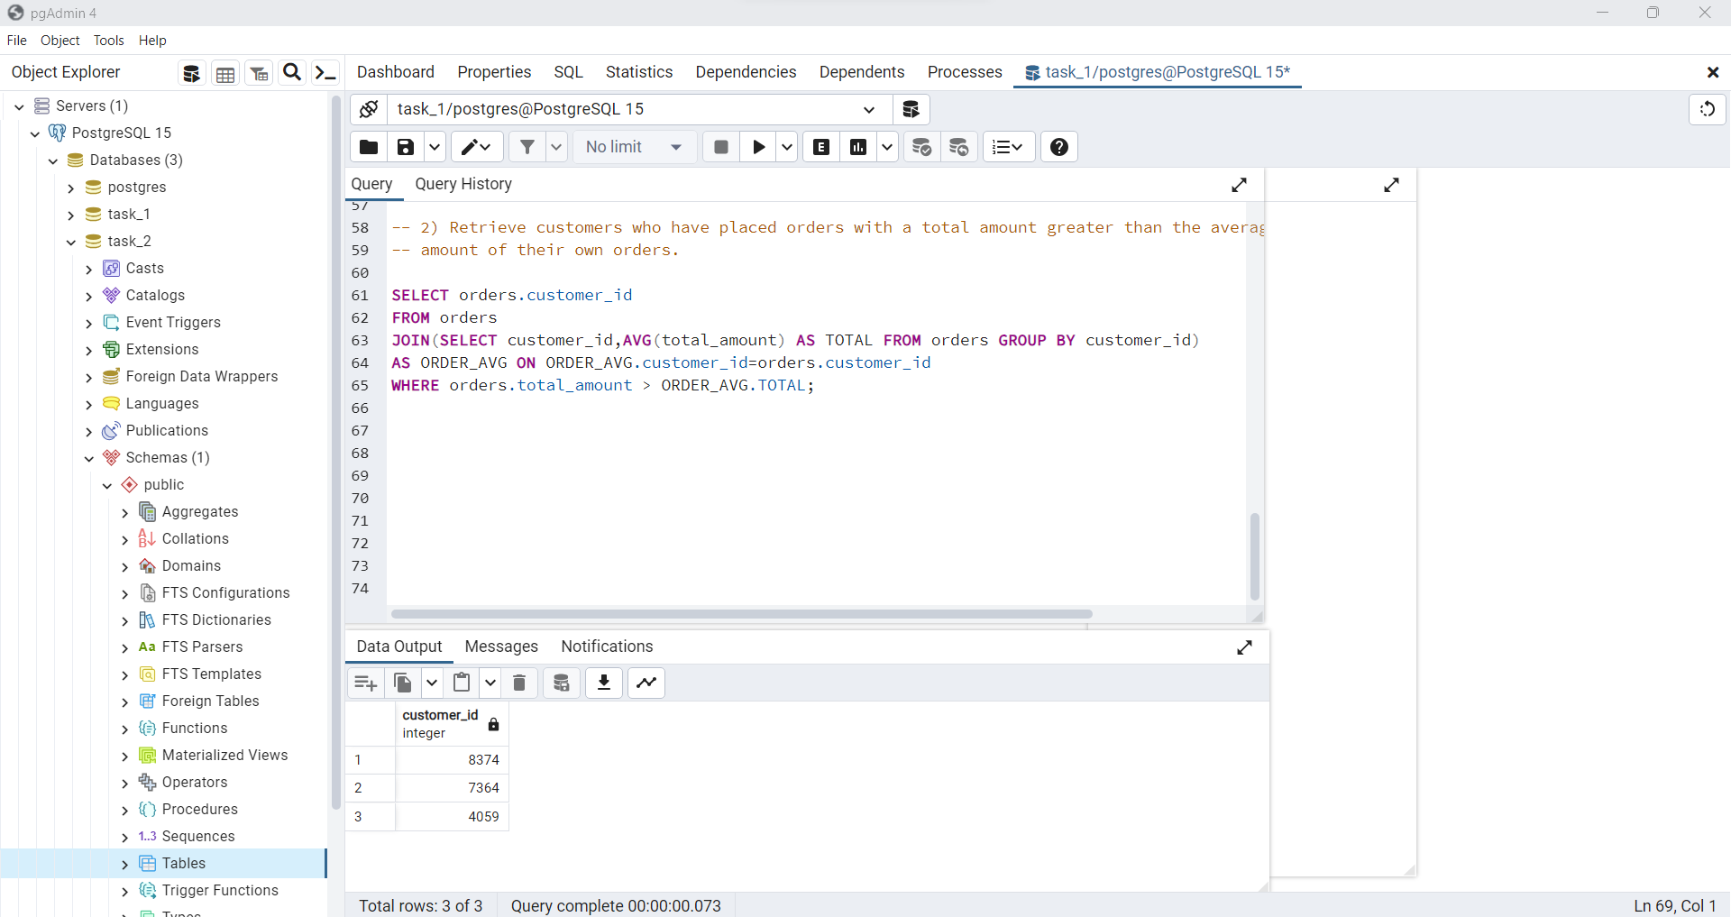

**Exercise 6: Pivot Table**

1) Create a pivot table that displays the total quantity of each product ordered by different customers.

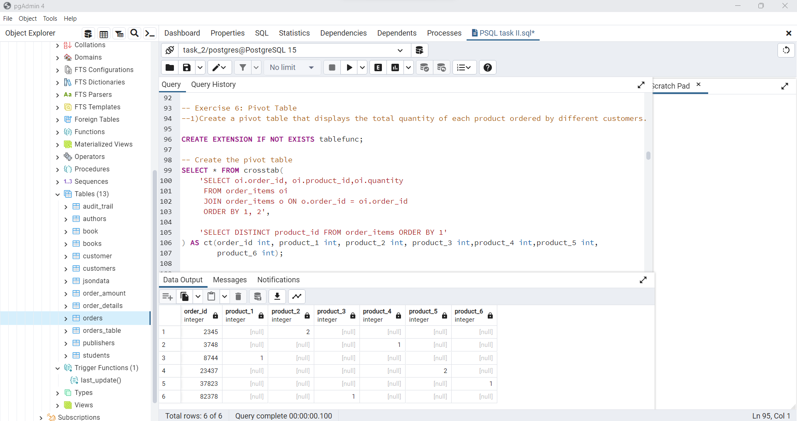

**Exercise 7: Database Design and Normalization**

1) Design a database schema for an online bookstore with tables for books, authors, publishers, customers, orders, and order items.

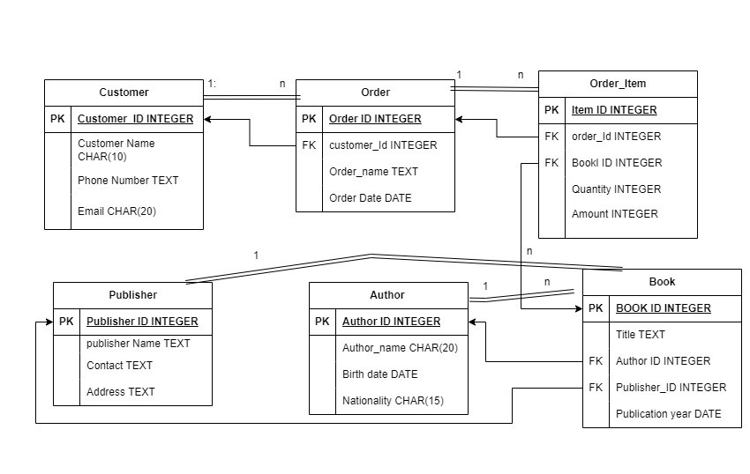

2) Implement relationships and constraints between tables to ensure data integrity.

* A single customer can place multiple orders.
* A single order can contain many order items.
* A single Publisher can Publish multiple books.
* A single author can write multiple books.
* A single order item can contain a single book.

**Exercise 8: Analytical Queries**

1)Given a table of customer orders, write a query to find the top 5 customers who spent the most money on orders.

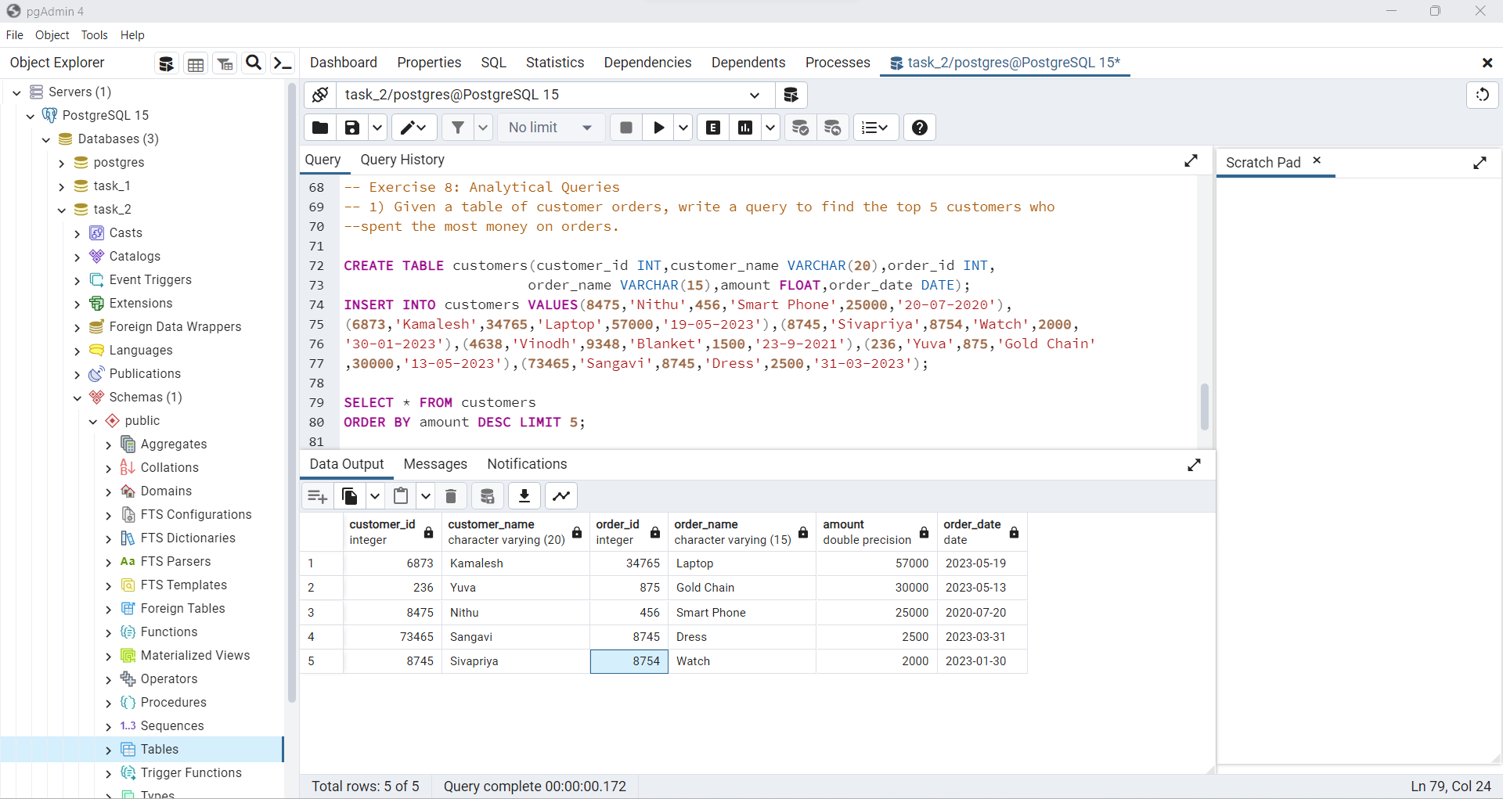

2) Write a query to find the top-selling authors (based on the number of books sold) along with their total earnings.

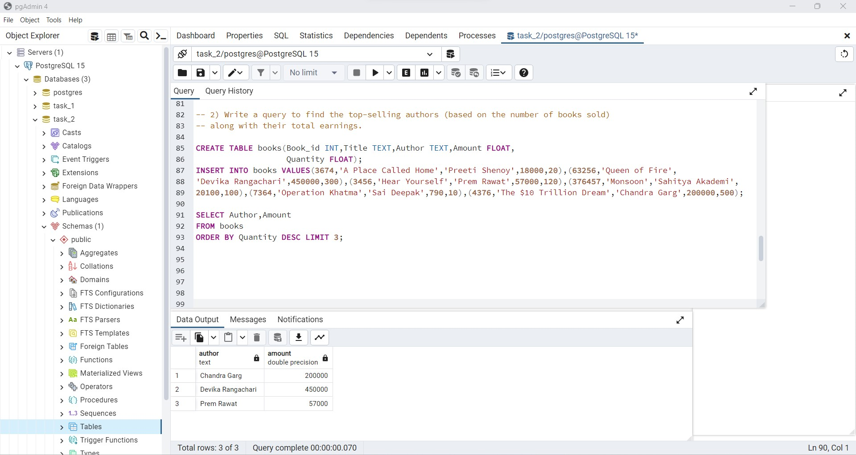

**Exercise 9: JSON Data Handling**

1) Create a table with a JSON column to store additional information about books, such as reviews and ratings.

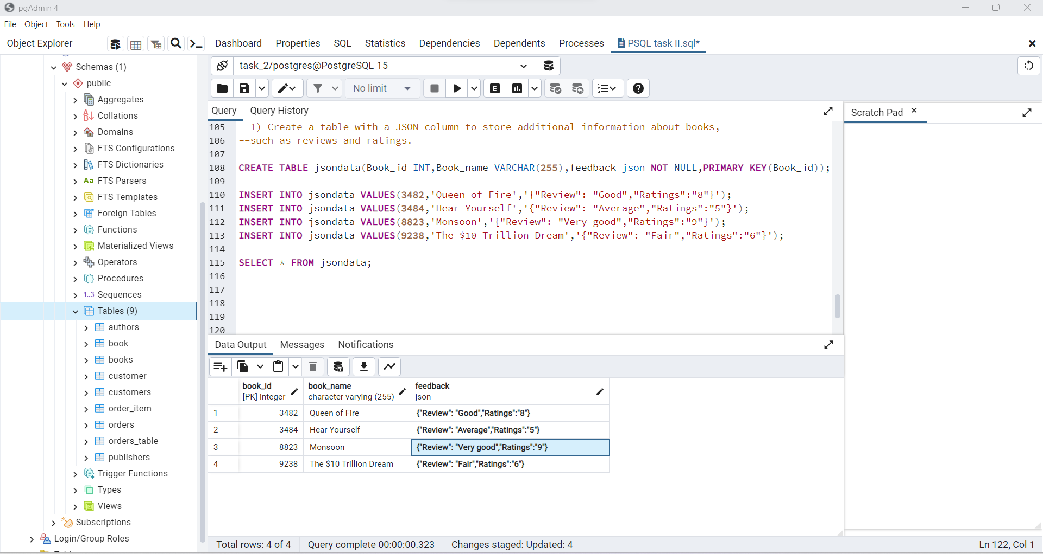

2) Write a query to retrieve books that have an average rating higher than a specified value.

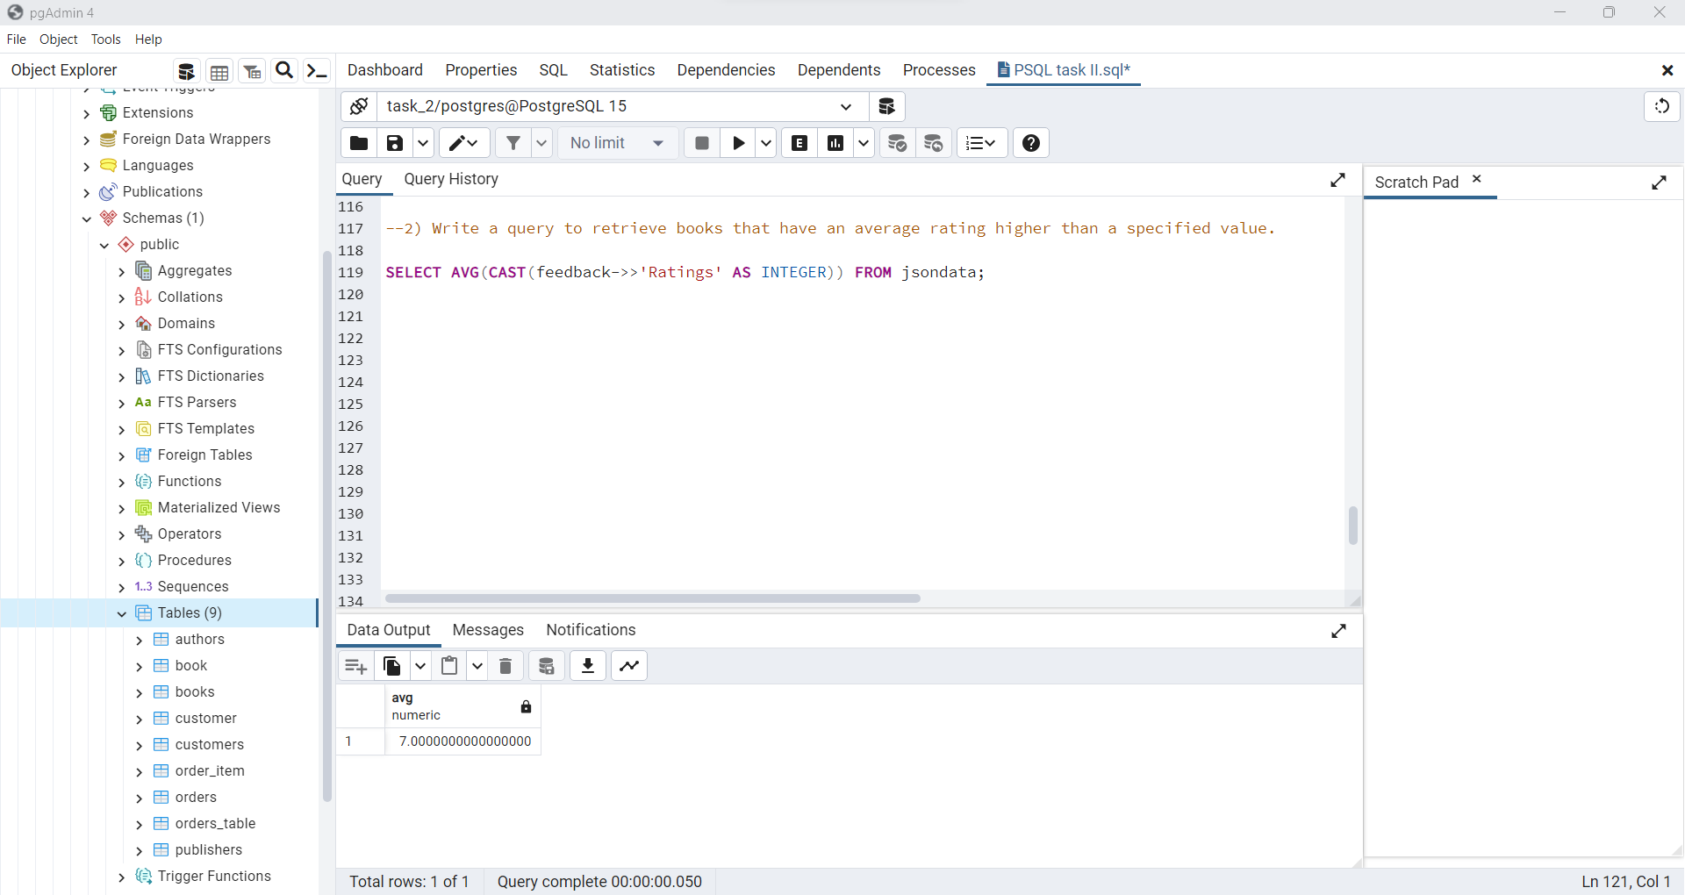

**Exercise 10: Data Modification and Transactions**

1) Create a stored procedure that, when given a book ISBN, updates the book's price by a certain percentage.

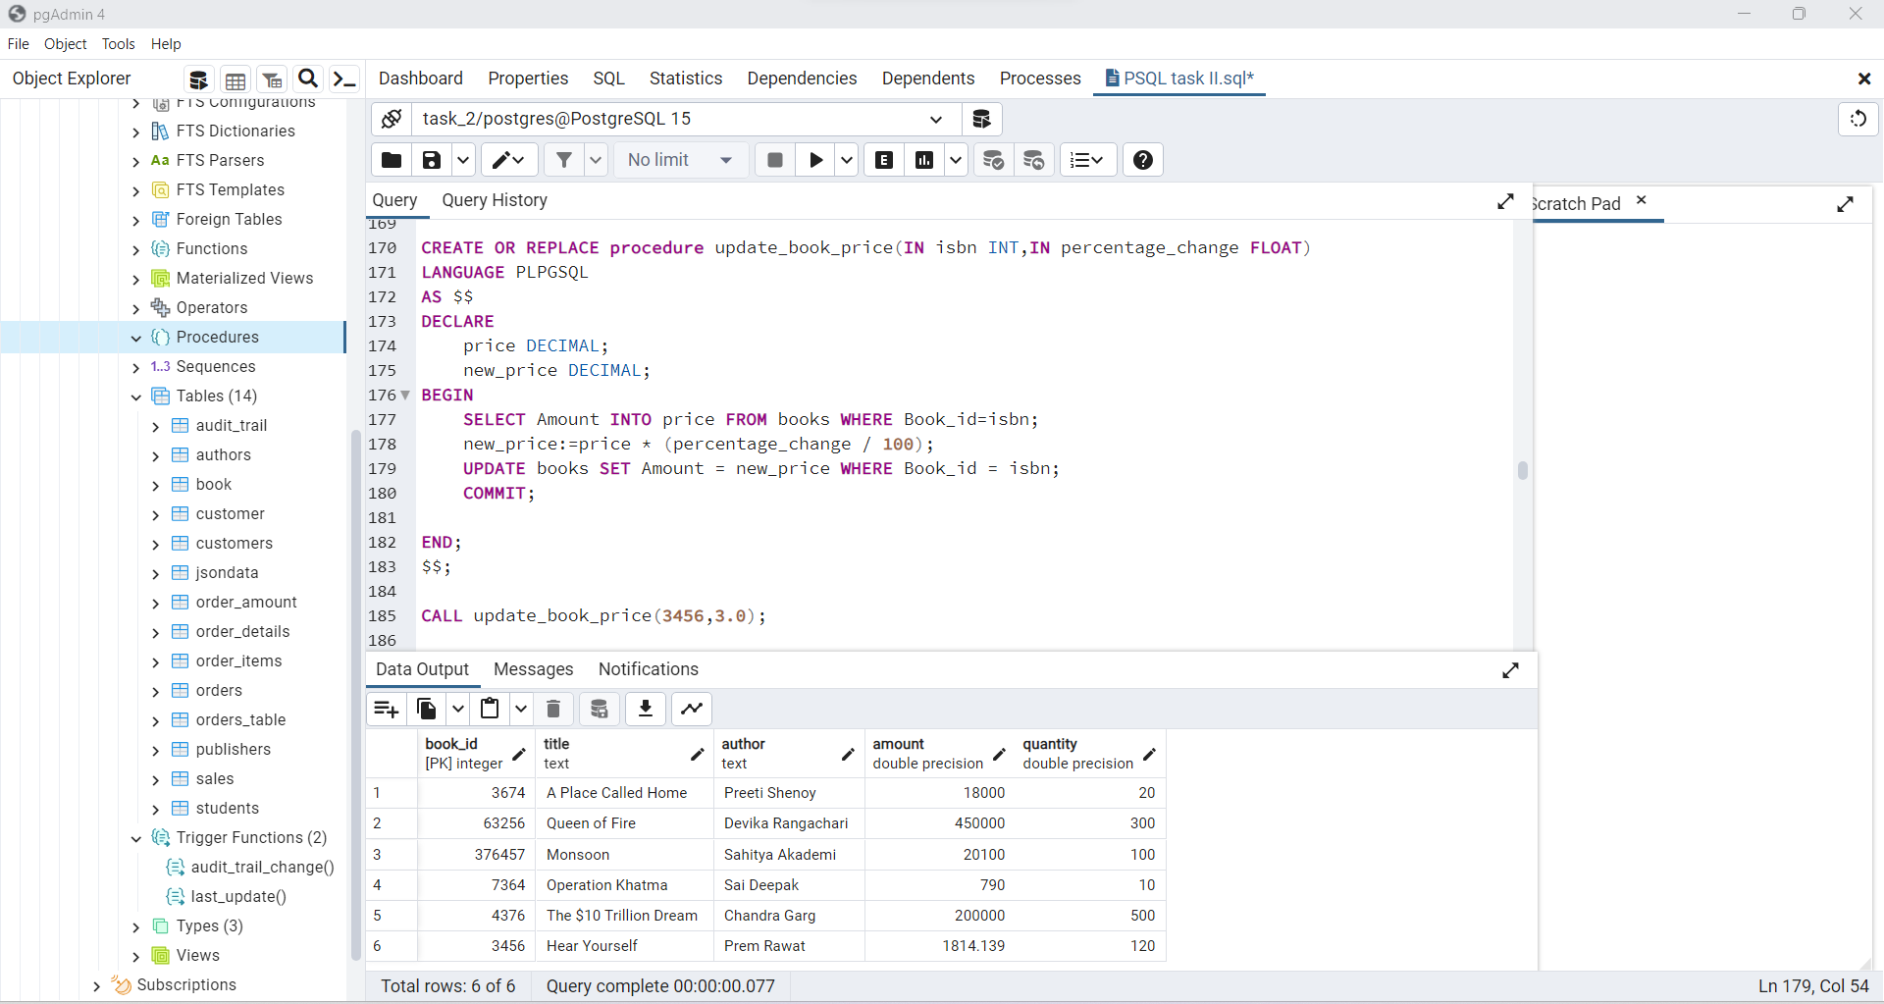

2) Implement error handling and transactions to ensure that the update is either fully committed or fully rolled back.

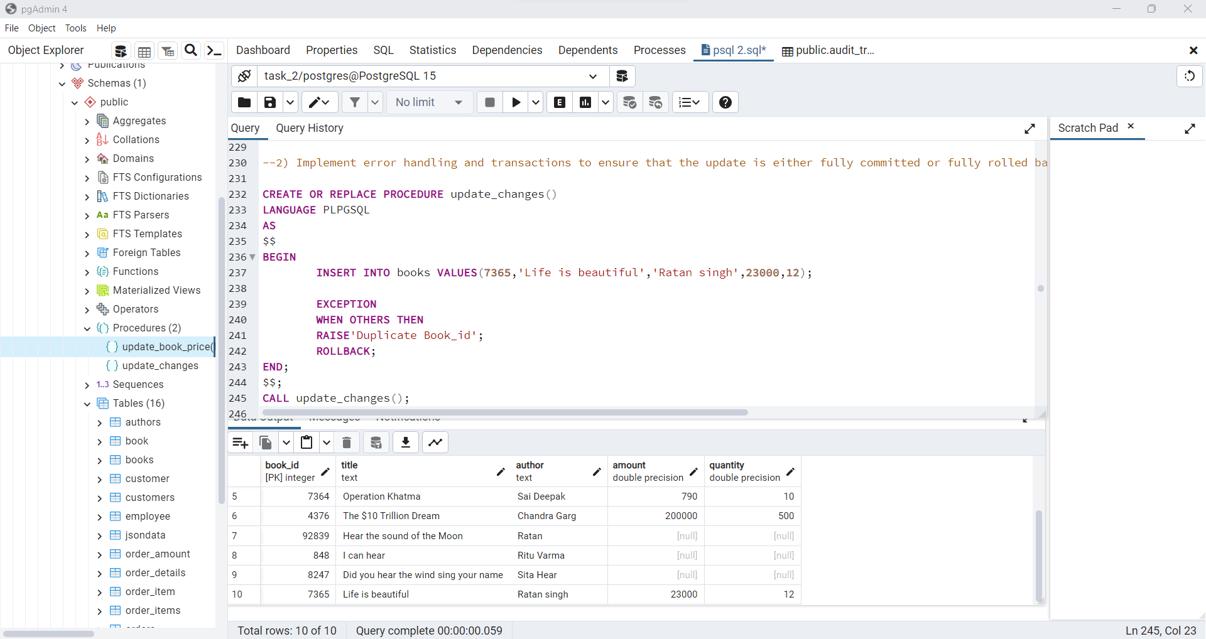

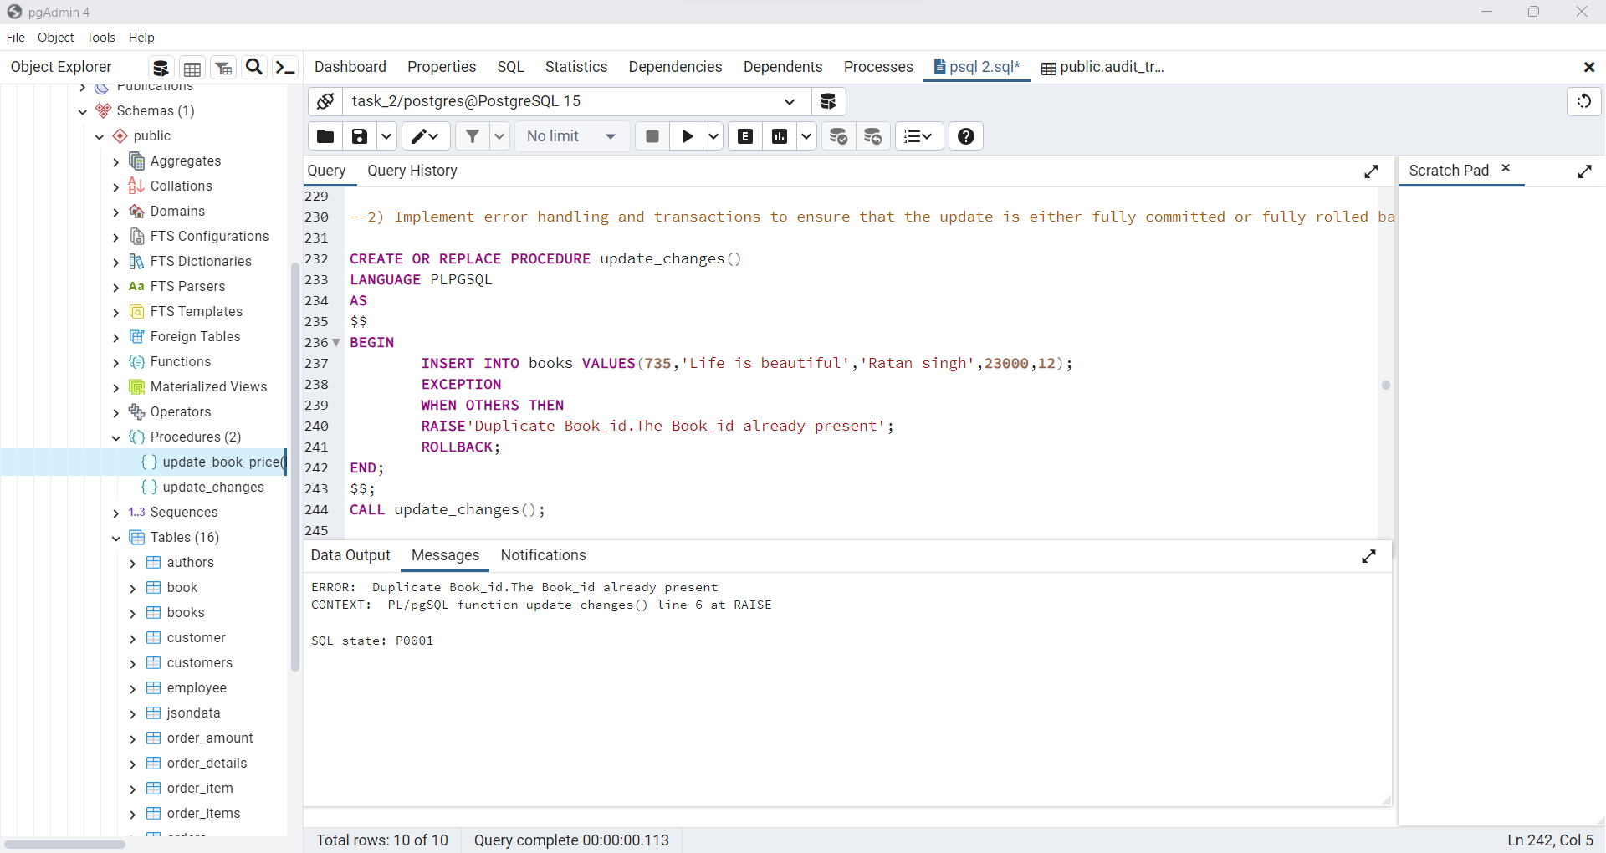

**Exercise 11: Advanced Window Function:**

1) Calculate the moving average of a product's sales quantity over a rolling 7-day window.

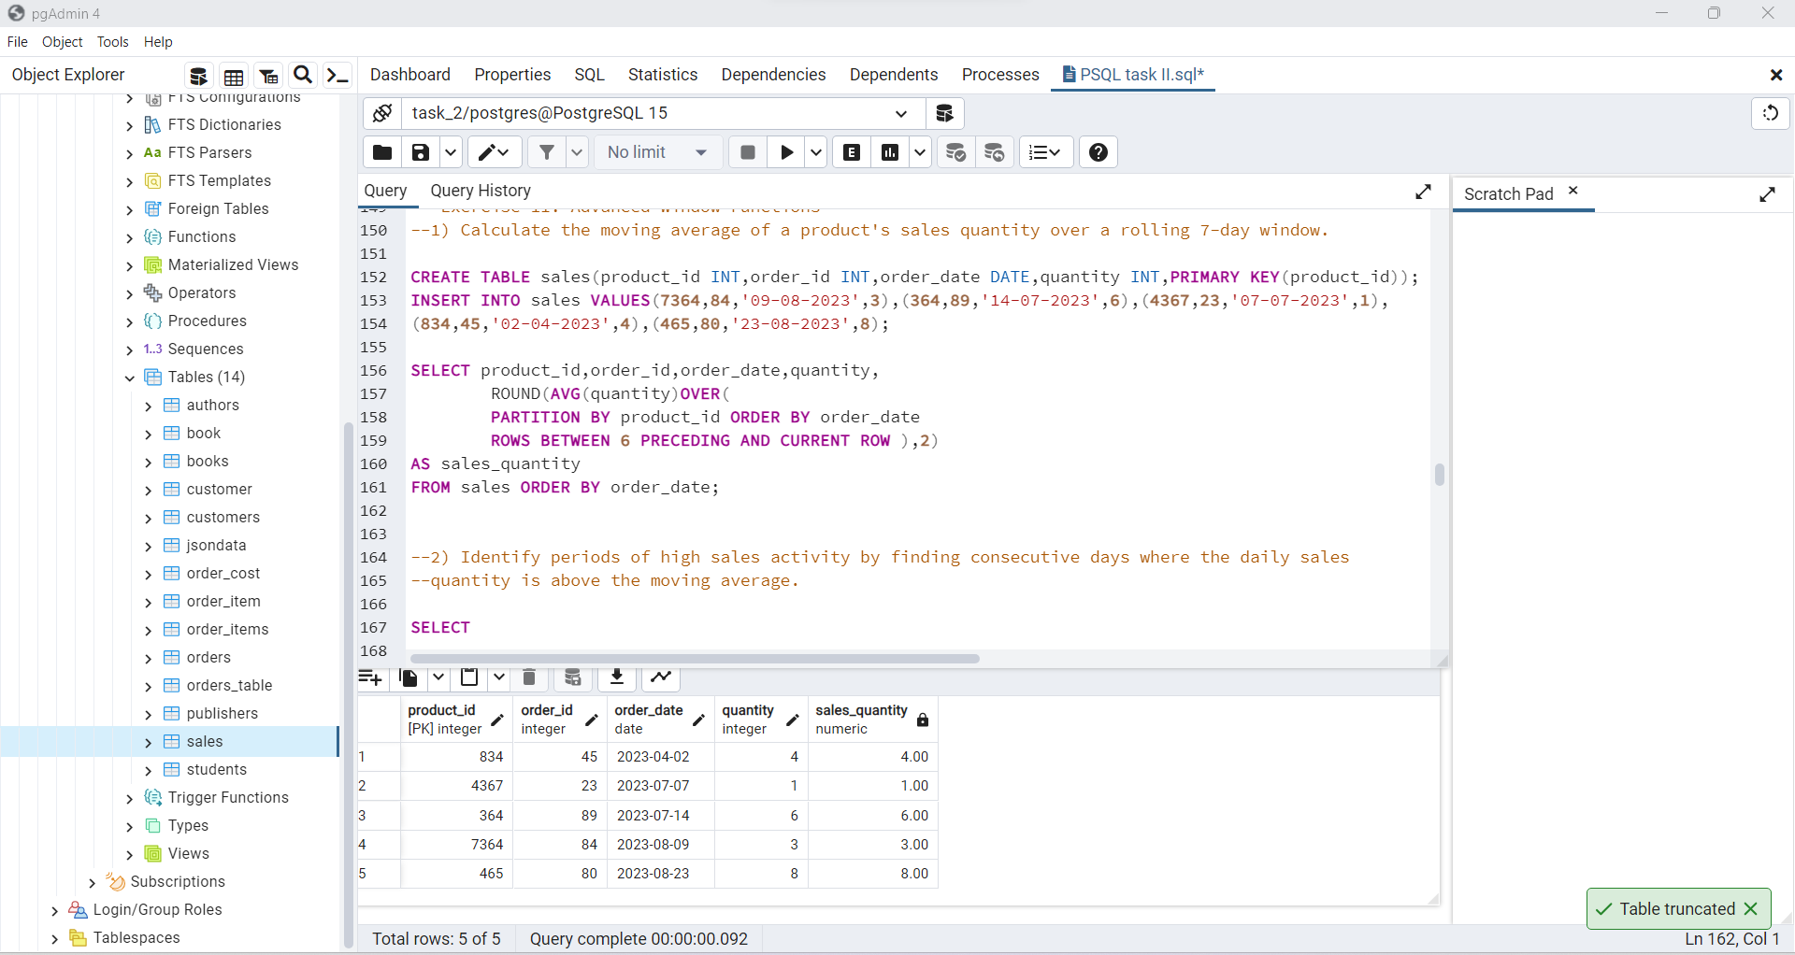

2) Identify periods of high sales activity by finding consecutive days where the daily sales quantity is above the moving average.

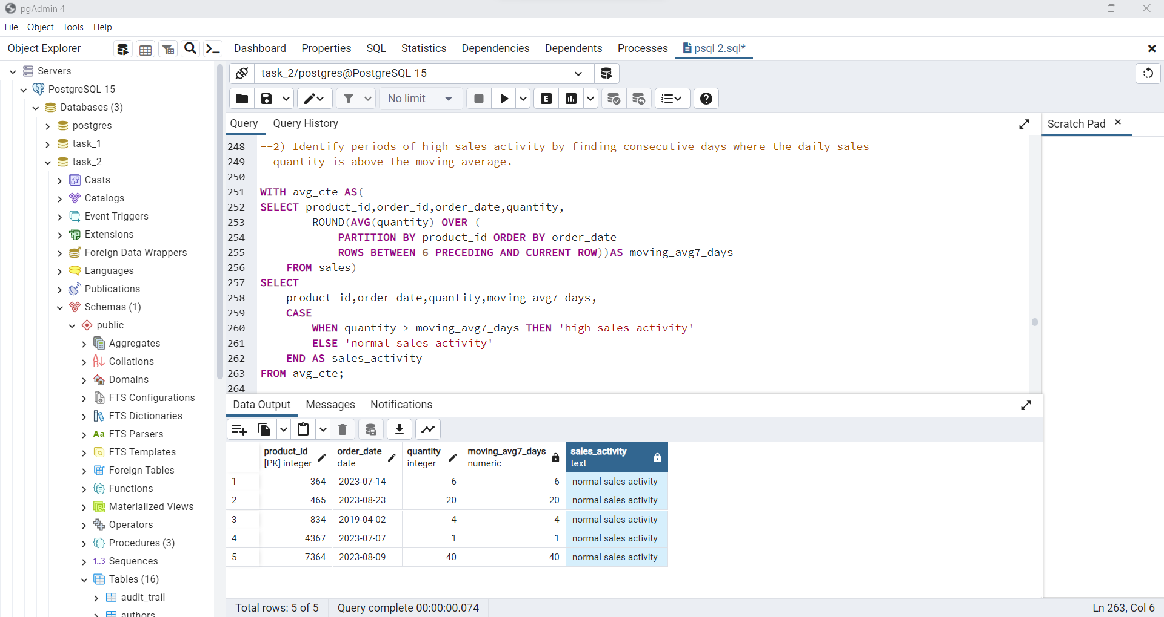

**Exercise 12: Full-Text Search**

1) Implement a full-text search for books based on their titles and descriptions.

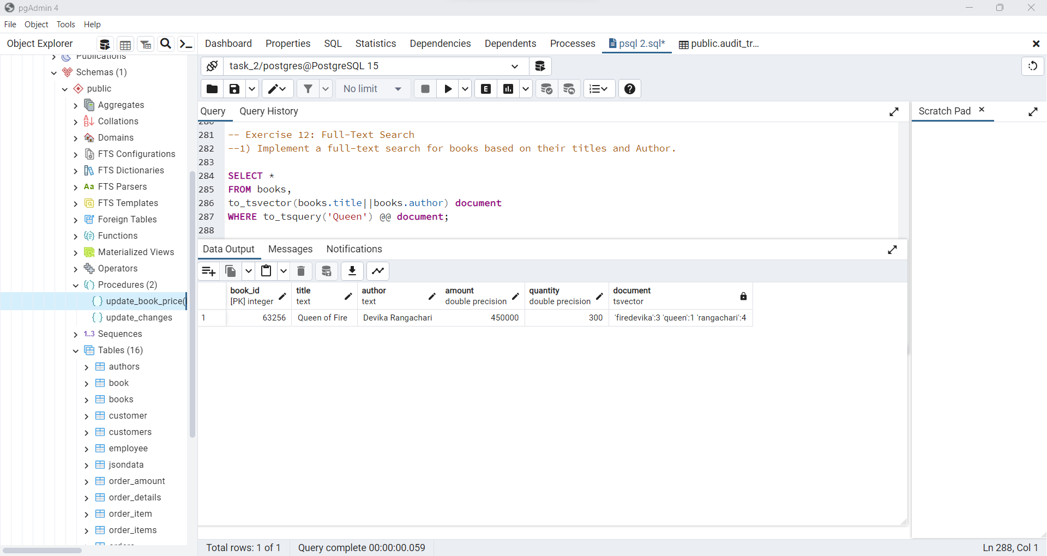

2) Rank search results by relevance and display the top matches.

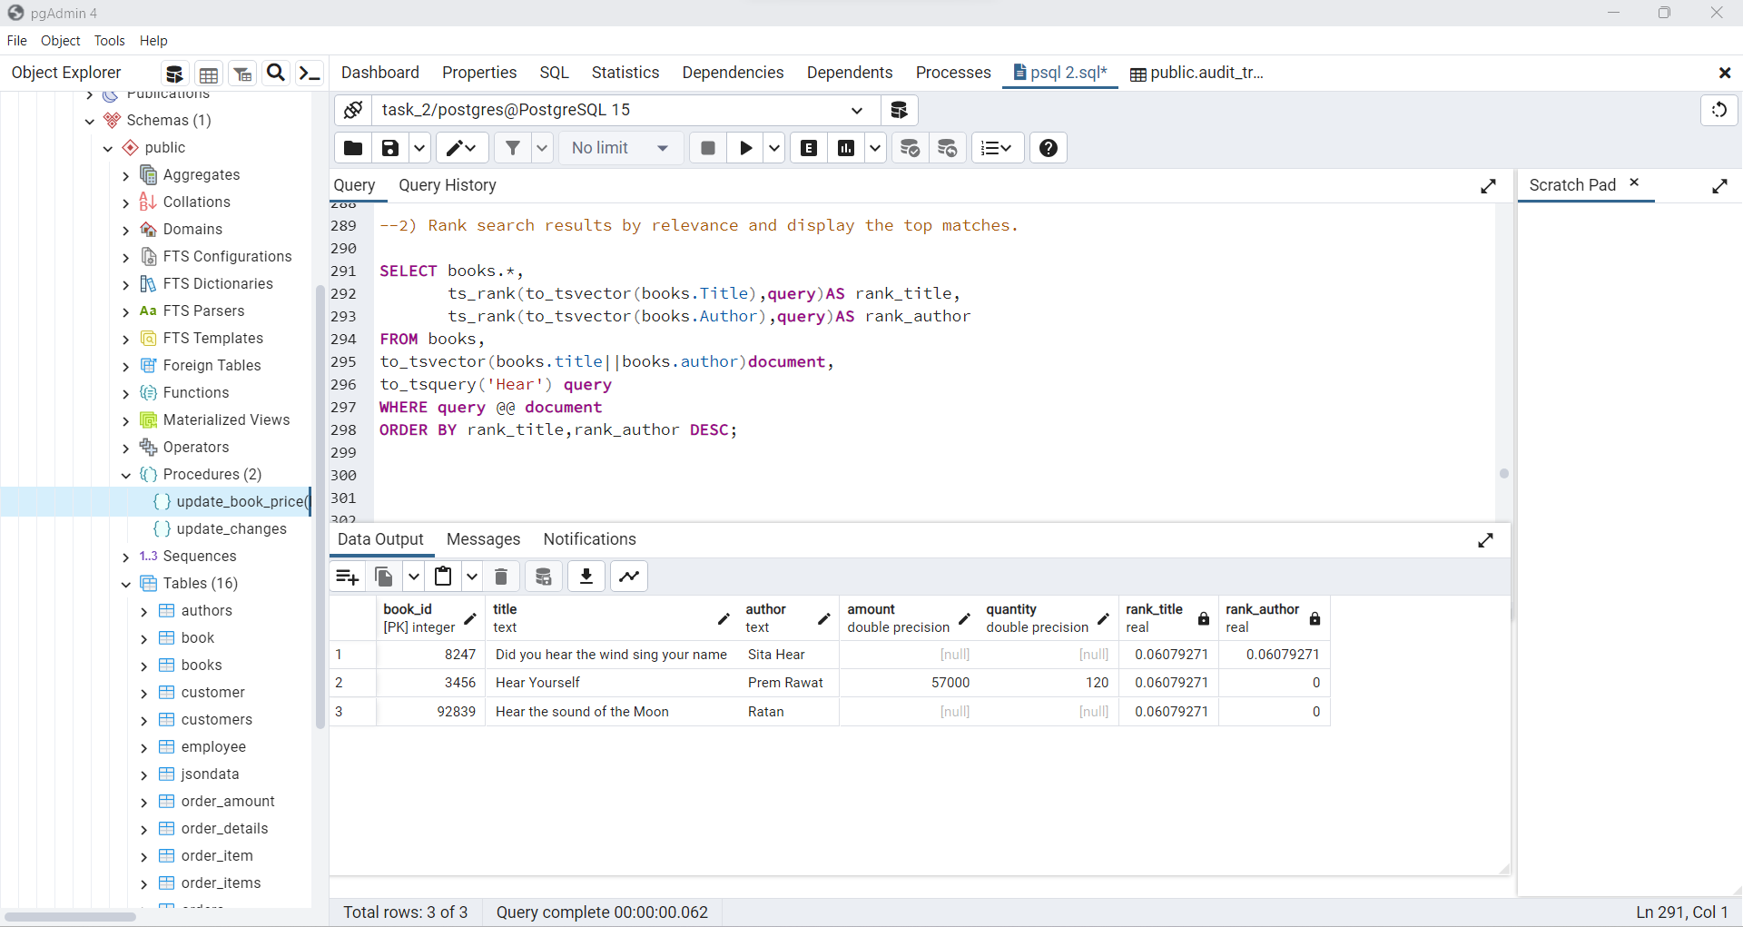

**Exercise 13: User-Defined Functions**

1. Create a user-defined function that calculates the total cost of an order, including taxes and shipping fees, given an order ID.

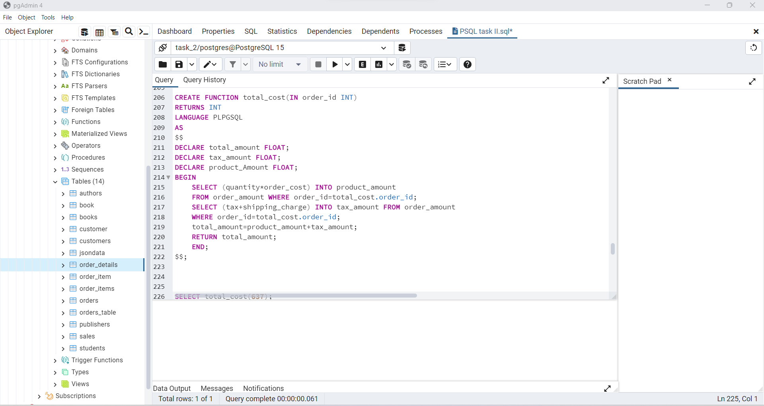

2) Use this function to retrieve the total cost for a specific order.

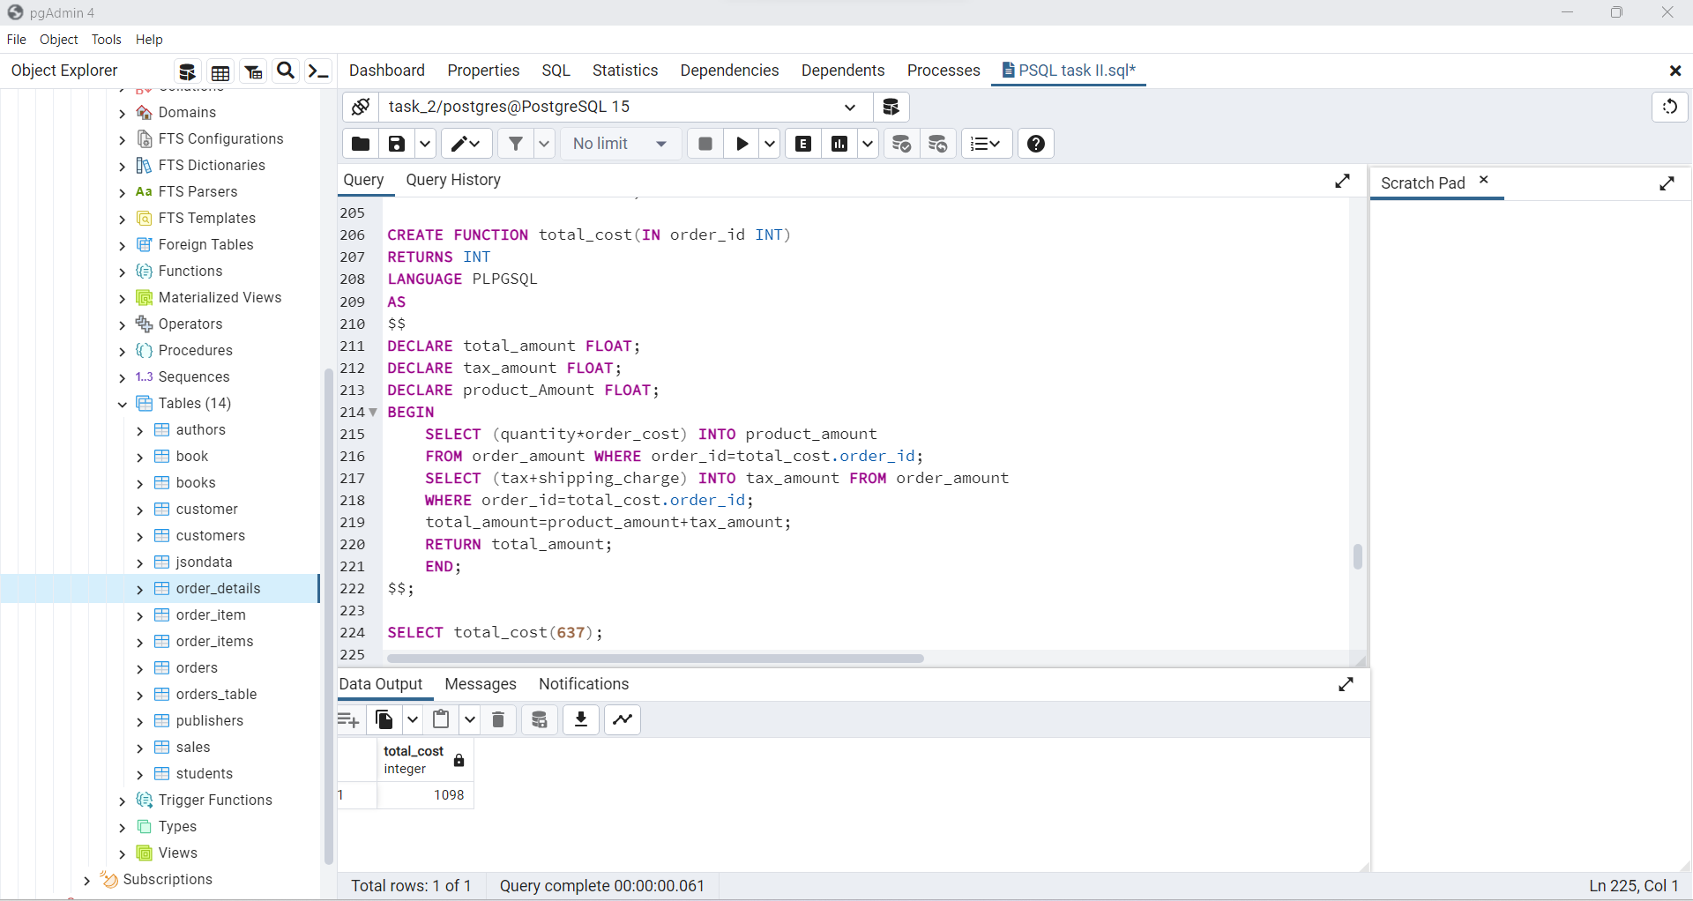

**Exercise 14: Triggers and Auditing**

1) Implement a trigger that automatically updates the "last_updated" timestamp whenever a row in a certain table is modified.

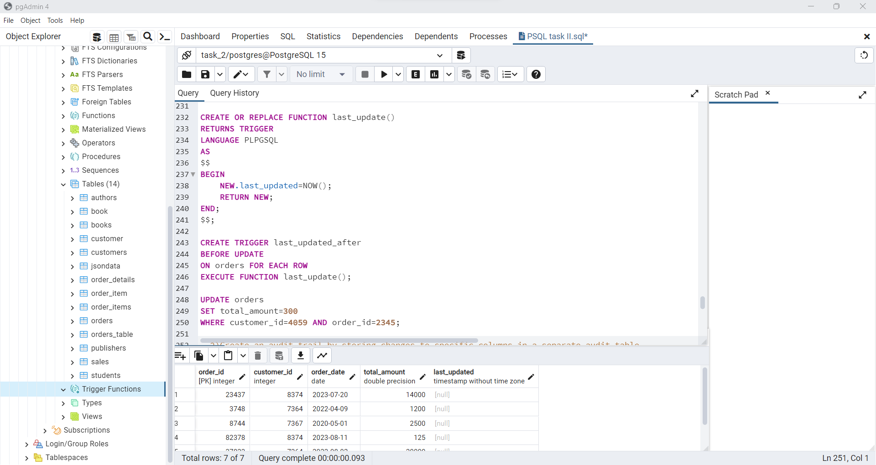

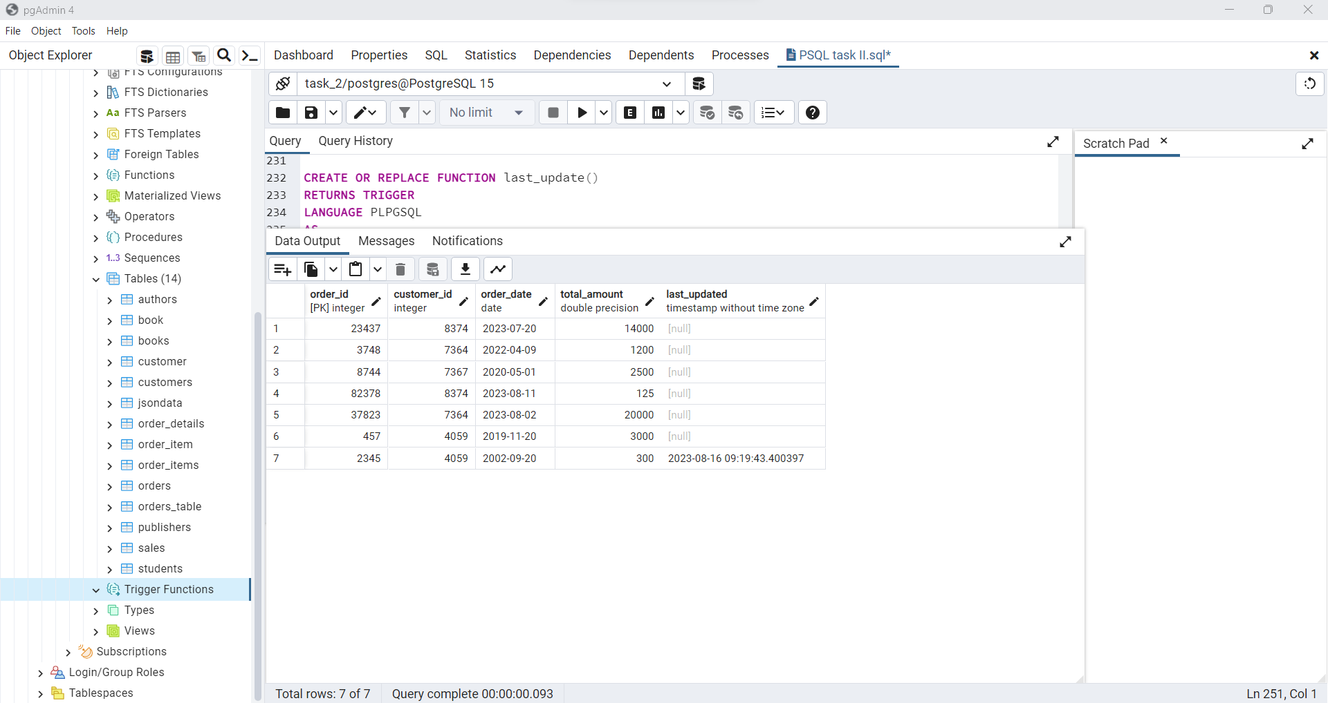

1. Create an audit trail by storing changes to specific columns in a separate audit table.

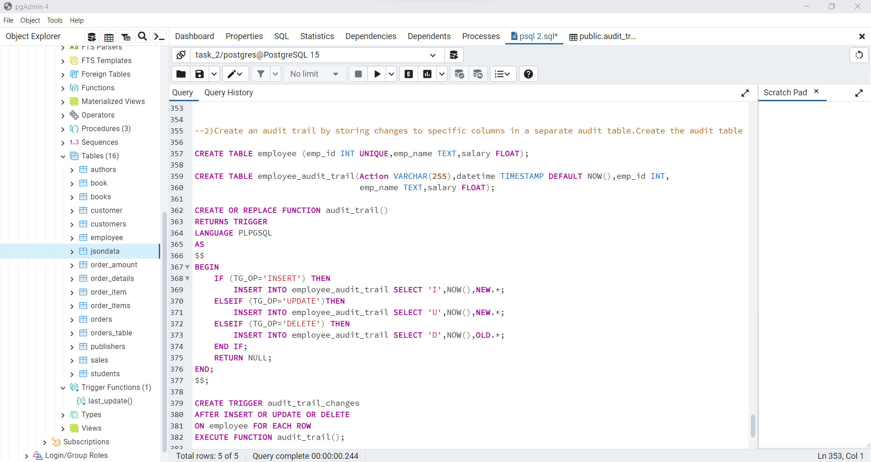

**Employee_audit table:**

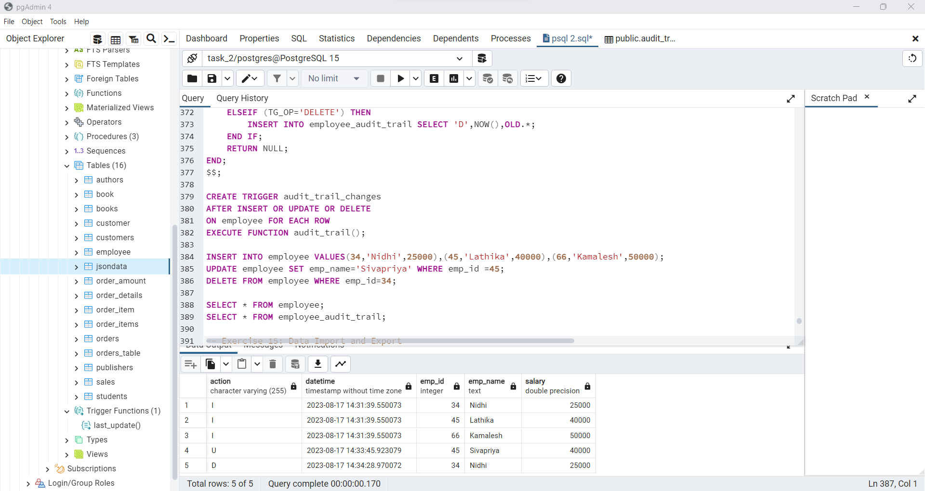

**Employee table:**

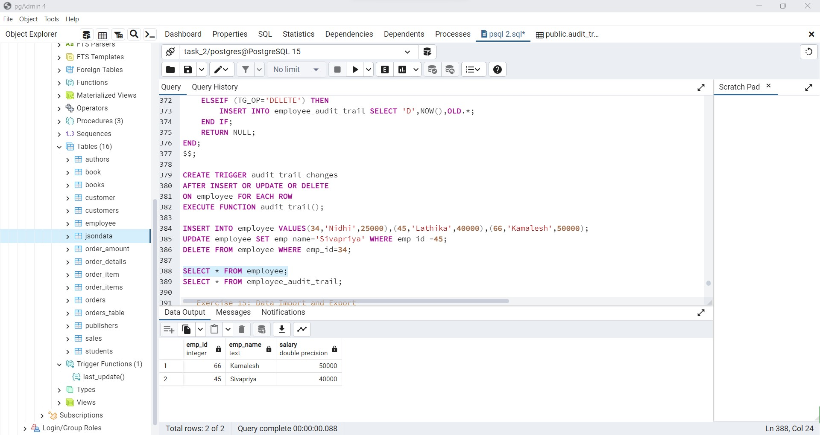

**Exercise 15:** **Data Import and Export**

1) Import data from a CSV file into a PostgreSQL table using the COPY command.

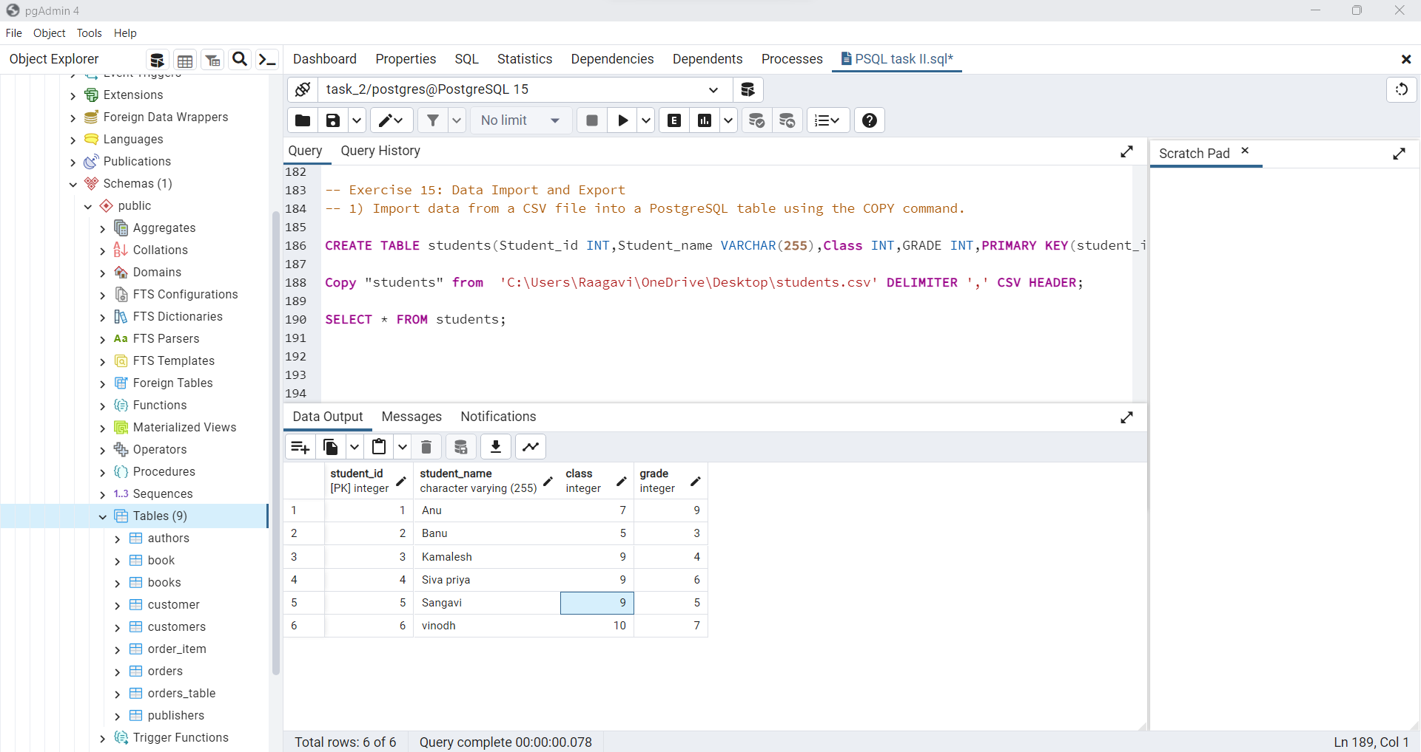

2) Export the results of a complex query to a CSV file.

